Senior Secondary Physical Education Elective
Part 5 Physiological Basis for Exercise and Sport Training
Worksheet 3

Battling ropes training becomes very popular recently, many sports coach will select this exercise as part of the training program. The following training programs are commonly found in many of sports training sessions.

Program | A | B | C
Exercise | 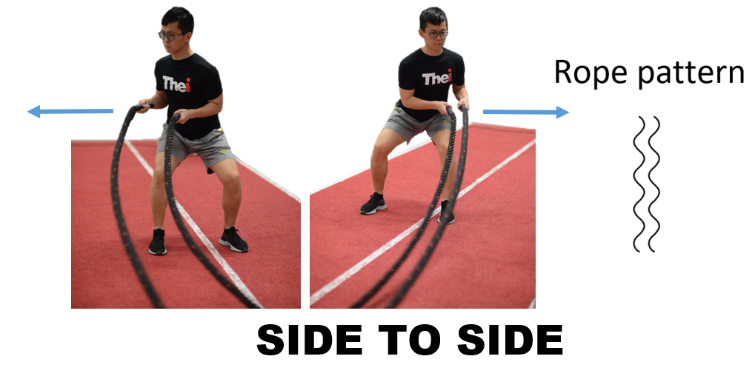 | 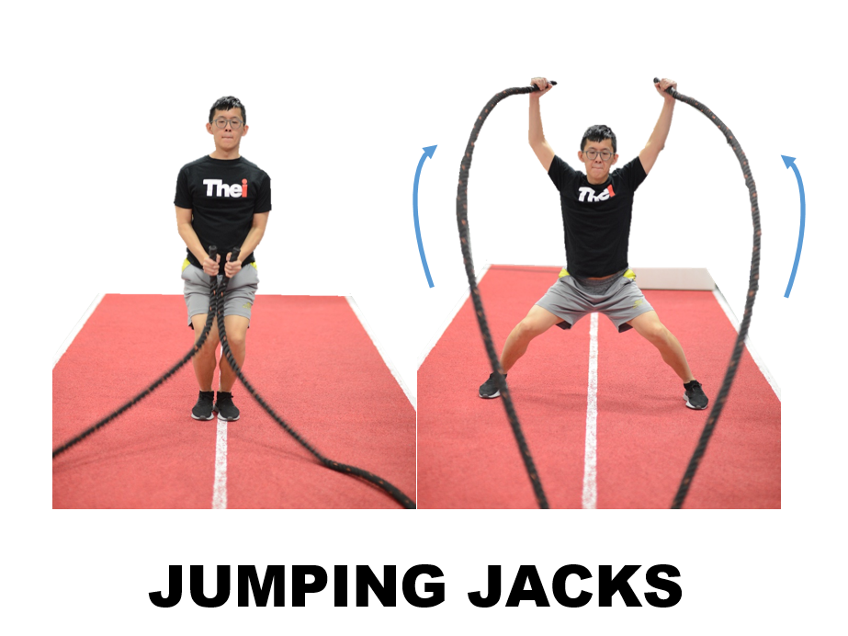 | 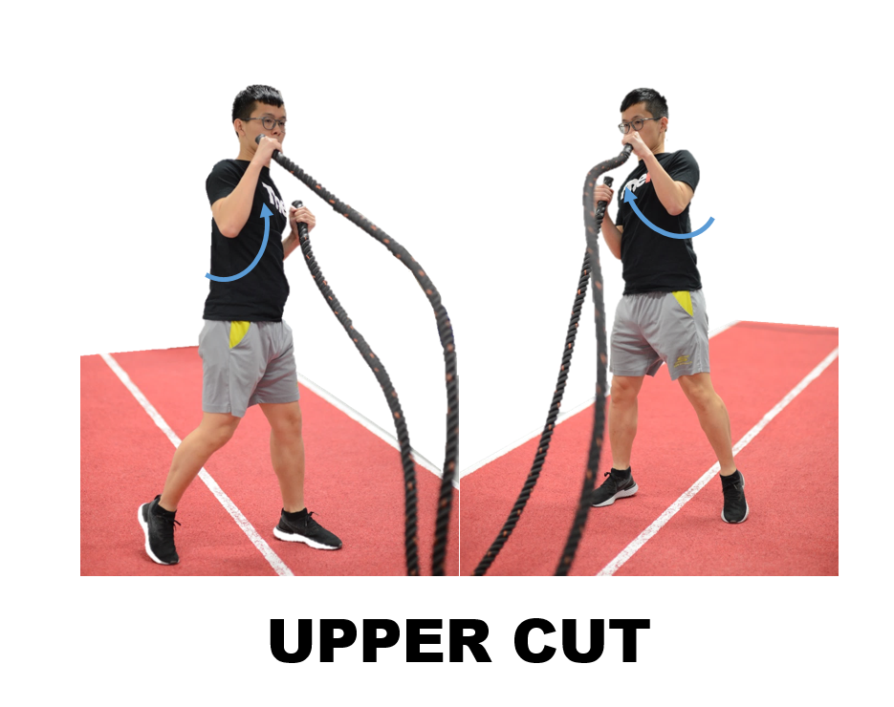
Duration | 20s | 60s | 10s
Rest time between reps | 20s | 120s | 60s
Repetition | 10 | 8 | 3

Question 1:
State the target energy system in Program B going for?

Anaerobic glycolysis system

Question 2:
A tennis coach would select Program A in a tennis training session for strength the power of forehand and backhand stroke, please state which energy system does it target for and which one training component should be revised, how?

ATP-PC system
Rest time between reps. The work : rest ratio should be 1:3 or above and so 20s should increase to 60s or above.

Question 3a:
Explain why the boxing coach selected Program C for the strengthening of upper cut technique in boxing exercise using specificity principle of training.

Specificity - The muscle groups utilised, fibre type, actions performed, environmental conditions and duration should all be taken into consideration.
The movement in Program C is very similar to upper cut in boxing exercise. Similar muscle group used, muscle fibre recruited, movement action.

Question 3b:
According to the overload principle of training, which component in Program C should be revised and how?

Should increase the number of repetitions.

References:
McArdle, W.D., Katch, F.I., & Katch, V.L. (2000). Essentials of exercise physiology (2nd ed.). Philadelphia: Lippincott Williams & Wilkins.
Åstrand, P.O., et al. (2003). Textbook of work physiology: Physiological bases of exercise. Champaign, IL: Human Kinetics
Earle, R., & Baechle, T. (2003). NSCA’s essentials of personal training. Champaign,
urpose;eplans are implemented; IL: Human Kinetics.

